Forum Documentation

By Joshua Muiruri 12.13

Contents

Analysis 4

Problem Identification 4

Stakeholders 4

Questionnaire 6

Responses 8

Research 9

Essential Features 11

Limitations 11

Requirements for solution 12

Hardware 12

Software 12

General requirements 12

Success criteria 13

Design 14

Breaking down the problem 14

How the user interacts with a website analysis 14

Usability features 15

A clear layout 15

A toolbar/dropdown menu 16

A help page 16

Well formatted content 16

Usable Forms 16

Algorithms of the code 16

Register 16

Login 17

User interfaces 19

Login and Registration 19

Dashboard/ Homepage 19

Key components 20

Test Plan 21

Post Development Questionnaire 22

Development 23

First Prototype 23

Registration page/backend 23

Login page/backend 25

Alpha Testing for Prototype 1 27

Test if register page prevents invalid password 28

Test if register page posts details to database 28

What requirements have been fulfilled? 31

What do the Stakeholders say? 31

What to improve for this prototype: 31

Second Prototype 31

Toolbar 32

Search bar 33

What requirements were fulfilled? 34

What do the stakeholders say? 34

What to improve for this prototype: 35

Third Prototype 35

Questions 35

Test if question buttons work 36

Question page 37

Question creation 39

Test to see if form page works properly 41

Test to see if form is saved 42

Updated Graphics 46

Fixed Search bar 48

Test for search bar 49

What requirements were fulfilled? 49

What do the stakeholders say? 49

What to improve for this prototype: 49

Evaluation 49

Testing 49

Test Evidence 51

Failed Tests 56

Usability Testing 56

Success Criteria Review 56

Solution for Unmet criteria 56

Final Review 56

Maintenance 56

# Analysis

## Problem Identification

The problem is that there is currently no site online where Biology can be discussed as a community to better peoples understanding of different topics. A site like this has the benefit of being easy to navigate and easy to find answers to common questions and even start constructive discussions about the subject. Many sites act as question-and-answer forums where questions are asked, answered, followed, and edited by users on the internet, for example, Quora and Stack Overflow do it in this style, Quora has a variety of topics while Stack Overflow focuses on coding and computer science.

Personally, as someone who is studying biology at A-Level, I know that it can become very drawn out and tedious especially when browsing through long and in-depth studies. Therefore, a website like this will be a useful source of knowledge for students. Also, with enough interaction, it can become a place of collaborative learning. I intend to create a website in this style using the Django API in the backend which can make it complex without being difficult.

The problem is computable because the use of a computer will allow users to be connected and interact with each other. Also because of how technologically developed the world is now, younger people would be more interested in an electronic solution. This is easily solved through the development of a website that has the following features:

* A system to put forward questions and enter solutions
* An upvote system that allows users to like or dislike questions and solutions
* A trending page where the most trending questions by upvote are listed
* A way to log in and save questions/ forums
* An organised toolbar with different sections like revision, discussions, example questions, etc.

These features are made simpler by Django API since it handles the server, database and other backend features without being difficult to code. Django allows you to develop a website without some of the tedious parts of web development.

## Stakeholders

The primary client base for this website is made up of those who are older than 16 who are studying biology at a higher level (Starting at GCSE level).

The main group will be students aged 15-18 that are studying biology. They will use the site to discuss with others online about different questions and topics. They can choose to just look up detailed solutions to questions they find difficult while revising or they can even contribute some of their knowledge to the community of the website by answering questions asked. The website will be used as a good source of revision for students since they will be able to view and compare many essay questions with their own. Questions and forums will be organised into separate topics so students can find what they’re looking for efficiently.

One stakeholder that I have chosen is a 17-year-old student named Stephen who finds it difficult to revise biology when he has a test coming up. He specifically finds it boring to come up with example questions to answer to further his essay writing. Because of this, his test scores are lower than he wants since he normally loses marks in his essays. He wishes to push up his test grades from a C to a B and then an A if possible. The website should be a good source of revision material for Stephen, and he could even submit his essays to be peer-reviewed by the other students that use the website. This will let him identify mistakes and improvements that he could make that he never noticed. I will be asking him throughout development to put forward his ideas for any changes that he deems to be beneficial to him so that he can be happy with the end product.

Another stakeholder chosen named Mr Smith is a biology teacher that often finds it difficult to make students more interested in biology outside of lesson, which he believes would increase their grades. He suggests a website that his classes can interact on when doing revision or coursework would be helpful so the website I intend to create as a solution should solve his problem. Including a feature where he could create a separate forum for his class where he takes control as the admin would be beneficial in regulating what content is shared by the students. I will be asking him any ideas or features that he would like developed for his use of the website.

Additionally, another stakeholder I’ve chosen called Kwame is a 17-year-old student studying A-level Biology who is doing pretty well compared to the rest of his class since he averages A’s and B’s in all his exams and coursework. Although, he aims to improve his grades to and A* but can’t an efficient way of doing this without revising for hours on end every day. Having a website where he can view and take part in discussions allowing to reinforce his revision. He can also get a better understanding of topics that he isn’t as good. I will be considering any improvements that he suggests being changed in the solution.

My final stakeholder that I have chosen is the head of the biology department in my school. His name is Dr Adekunle, and he believes that the majority of students have a lot of potential but often in the first year slack off but then in the second year put in more effort and get better grades. He wants to change this so that students can be more consistent and higher achieving. He suggests a website that classes can interact on when doing revision or coursework would be helpful. The website I will create should be a good solution to this. I will be asking him for any features that he wants to include or alter throughout development.

## Questionnaire

I have created two questionnaires on Microsoft forms tailored to either students or staff to find out if the creation of this website is valid.

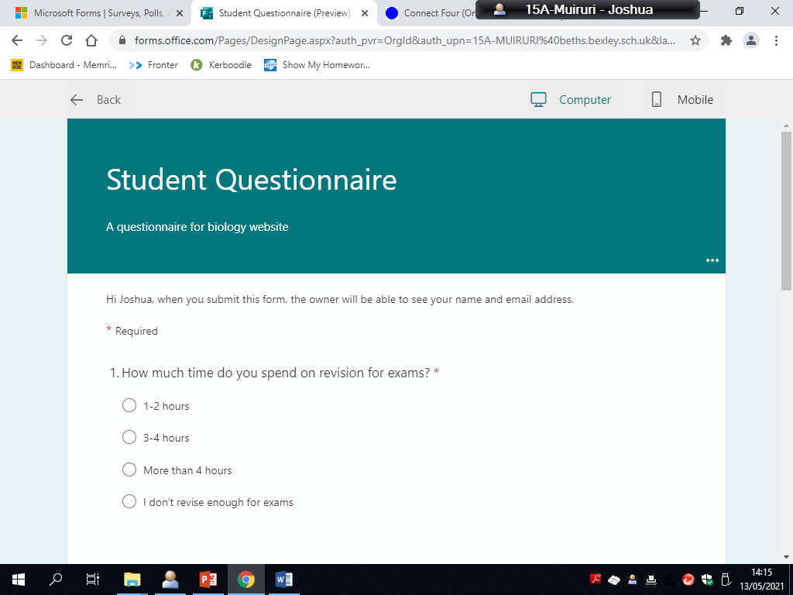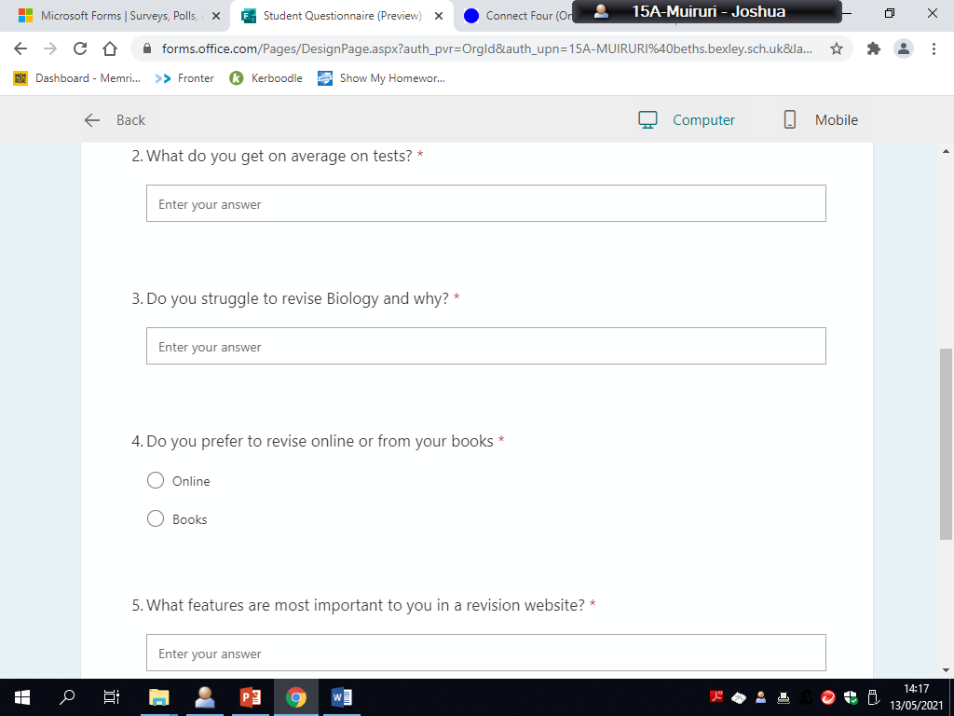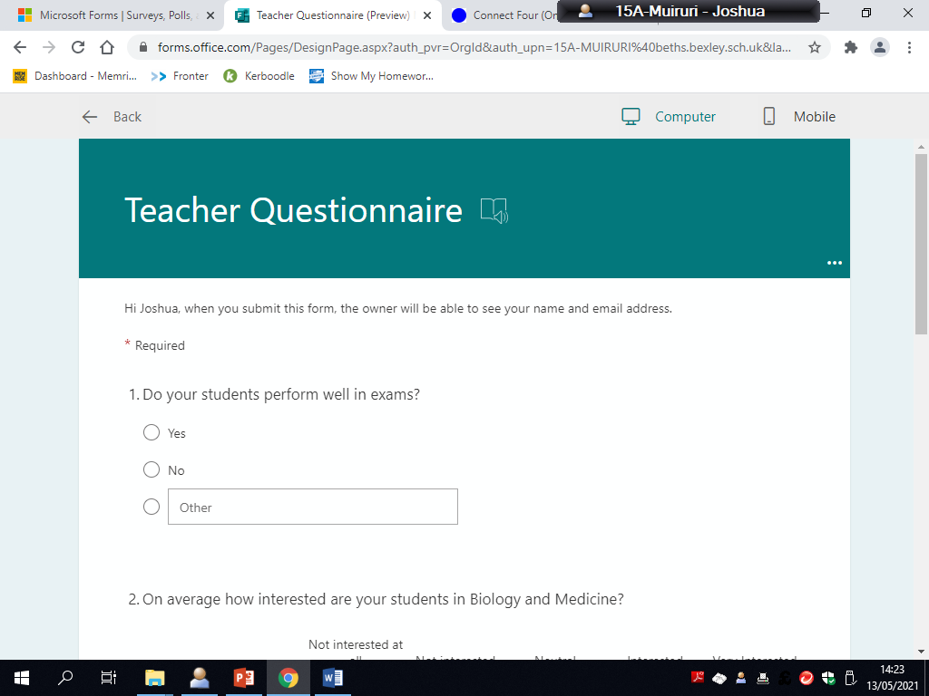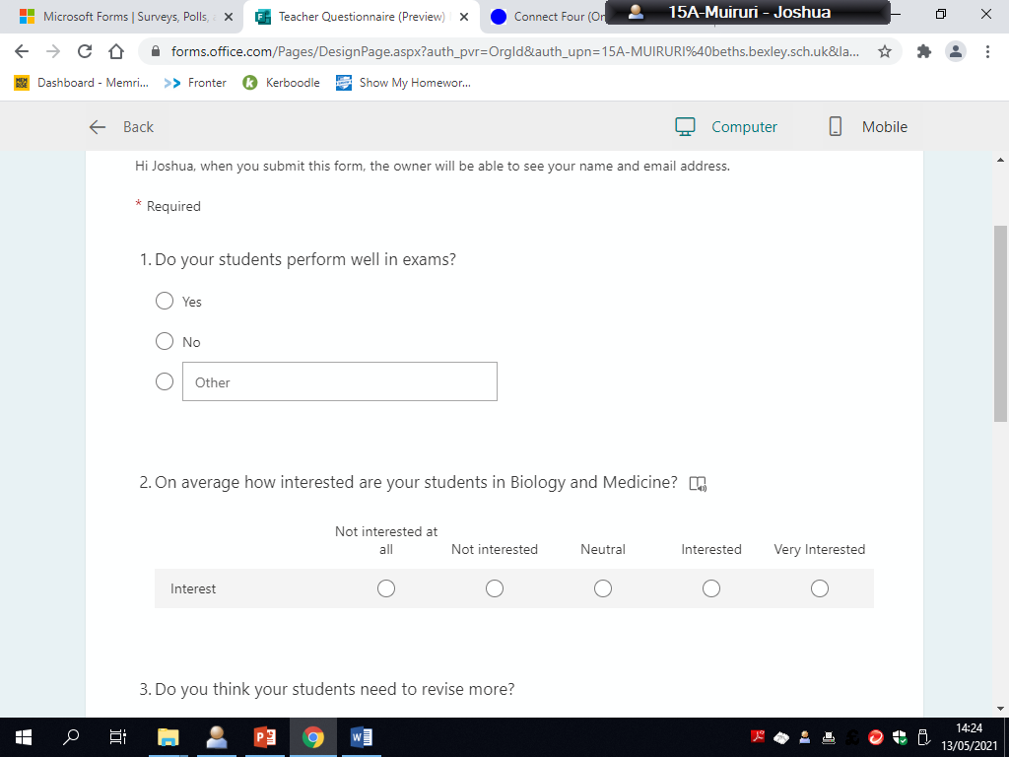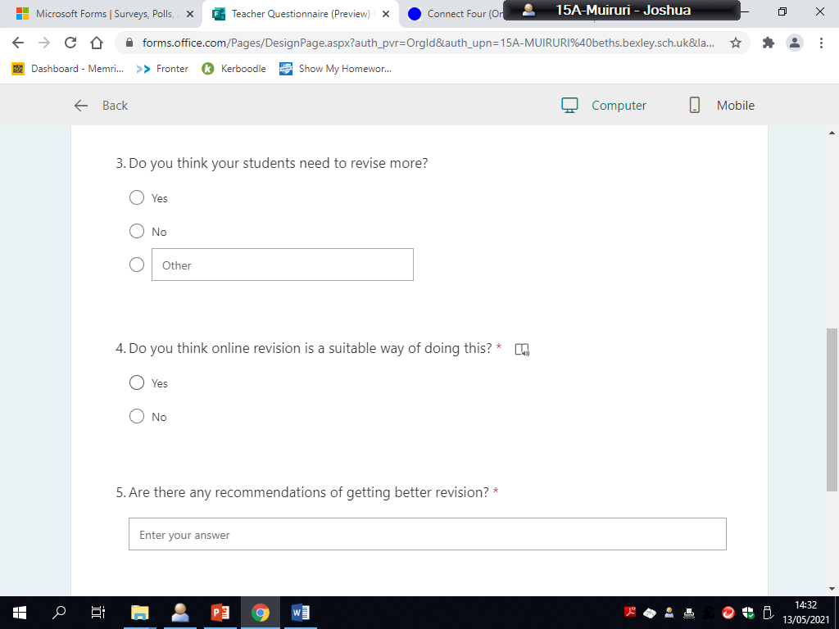

### Responses

Stephen – Student

1. I don’t revise enough
2. On average I get grades B-C
3. Yes, I struggle with writing essay questions which is the main part in exams that I struggle with and lose marks on.
4. Other – I normally study using my textbook by copying out pages of notes but, more recently I’ve been more inclined to looking online to find more simplified and concise notes and I use a revision website called Seneca learning.
5. I would want a way that students could interact, exchange and compare essay answers and other questions so that I can improve my essay technique. It would be nice if different answers were tagged or if I was able to save good essay answers for later. Saving discussions and questions would also be useful to look back at.

Kwame - Student

1. 3-4 hours
2. I get A’s and B’s normally
3. I don’t struggle to revise at all, but I can’t seem to get better results since I’m aiming to get an A* to get into the university I want to go to.
4. Other – I use a mix of both books and online, I my book to know exactly what’s required in the specification but tend to use online websites like physics maths tutor to print out past papers and questions to revise from.
5. I’d want a place to find answers to questions that I struggle on, but more importantly a way to compare my answers with people who are achieving A* grades to learn what works for them and how I can improve. Being able to have a personal account and save topics useful to me. Maybe if I discuss with them about the subject more, I can improve my interest and grades.

Mr Smith – Teacher

1. On average my students get Bs and Cs
2. Other – Half of the class is interested and intend to do biology at university, but the other half doesn’t seem to care that about biology.
3. Yes, extra revision is always going to benefit them since I would like more of my class to get higher grades like A and A*s.
4. With the right websites online websites can be good at assessing your knowledge.
5. Answering questions and doing past papers can help. Comparing and looking at good essays.

Dr Adekunle – Teacher

1. My students normally get grades ranging from A*- C
2. Interested
3. Of course, my students need to revise more since what you put in is what you get out of a subject.
4. Yes, this is a form of revision that many of my students are interested in
5. Doing past papers is by far the best form, once you know the content.

## Research

Similar example – Stack Overflow

<https://stackoverflow.com>

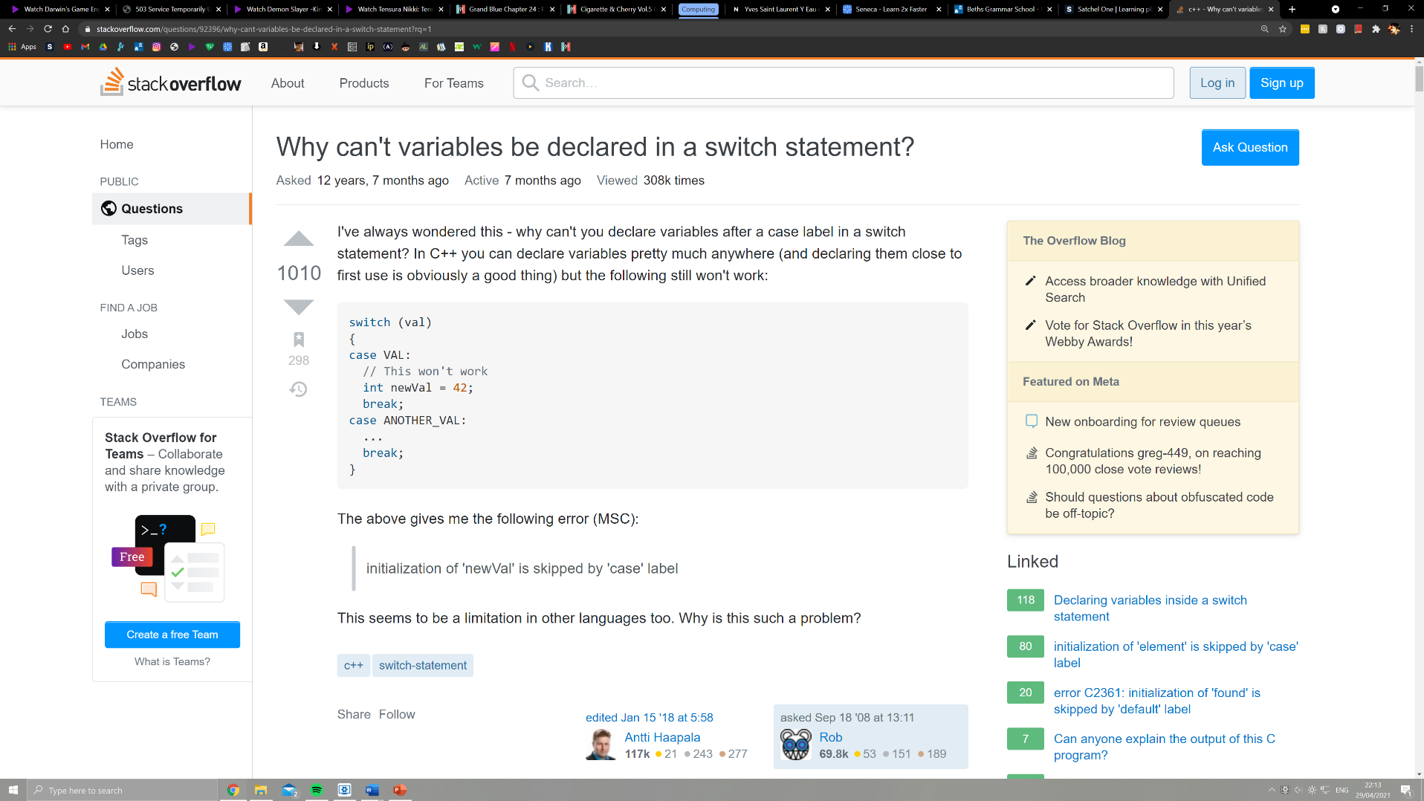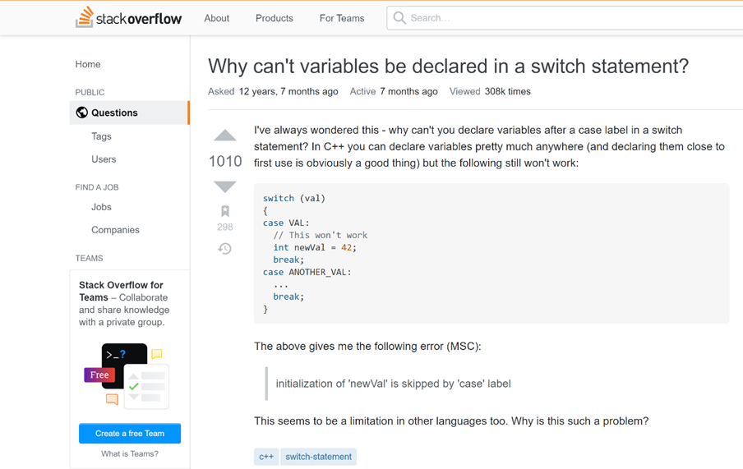

[Upvote system, include save icon](https://stackoverflow.com)

Stack Overflow is a question-and-answer style website that deals with any problem concerning computer programming. It was created on 15th September 2008 and since has become the most used website for learning programming, even professional programmers use it to solve parts of code they are stuck on. The website contains all the features that a basic site should have like a search bar, login system, toolbar linking to other pages, etc. It also effectively implements a Q&A and upvote system which are the key parts of the site. Users can submit and view questions on different topics and for each question anyone is able to answer with a solution. Users can upvote or downvote a solution to say if it worked or not, which could sort the answers provided. The website automatically displays the solutions in order of number of upvotes from highest to lowest, making it easy for users to find solutions that work for the most people. This makes the website a sort of community.

Stack overflow is a more educationally focused website in comparison to the other examples, making it the most like the website I intend to create.

Parts I wish to include in my solution:

The overall structure and concept of Stack Overflow is similar to my solution so it should be simple to apply features that will be useful. I am going to implement an upvote system into my website because it essential in sorting solutions to make the right information easier accessible for users. The idea of using an upvote system to sort solutions to questions is clearly effective and would fit well in my solution. The inclusion of this idea will be appreciated by Stephen who would want to find the best answers as quickly possible when searching through the website.

Similar example – Quora

<https://www.quora.com>

[Account icon](https://www.quora.com)

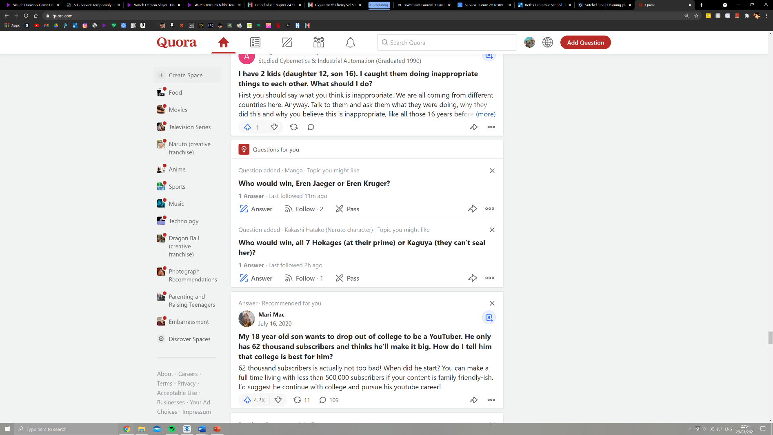

Quora, founded in June 2009, is a more of a social media website that is to discuss any question that is brought up. There is no specific focus of questions asked/ forums started, it is all down to the users. Users are able to create accounts on this website allowing a history of questions that they interacted with to be formed. Having an account also allows them to save favourite forums or topics for the next time you log in to the website. Quora then, through the use of an algorithm, recommends you questions that it believes you might like to make you keep using the site.

Quora sorts questions into different topics so that users can find questions that they want to view and interact with. This is different in the way that it allows users to post images and videos making it lean more to being a social media site, but at its core is still a question-answer website.

Parts I wish to include in my solution:

The idea of having a way to create an account and save topics for users is essential to long term usage of the website. If users are given a way to save what they do on the website, they should have a higher chance of using the site again. This will make students more inclined to use the website for biology more often making it build its user base more. This addition should be well appreciated by Stephen who would want to save solutions to questions and topics he doesn’t understand when revising or completing essays.

## Essential Features

One essential feature of my solution is that there needs to be a section of my website where users can make questions, answer and discuss questions which would make it similar to a forum. All questions will be stored on the site’s database through Django. This would allow users to communicate with each other and could increase how often they come back to the website. This is the main feature of my solution that makes it slightly unique to a forum.

Another essential feature is that it must have an upvote and down vote system. This will allow users to assess if a question or solution is good or not and will make it easier for users to find the most viable answers making traversing the website easy. You would be able to compare different answers quickly

Another essential feature is to have a search bar where you can search through all of the current questions and tags/topics. This is useful because it allows users to sort through and access questions that they are concerned with like on a specific topic.

The website needs to have a login system where you are able to create an account and log in to it with an email and password. This is useful because it will let users save questions, and answers that they submitted but also your account will be accessible by other users to see your answers.

A section of the website where classes/rooms can be created, and teachers can be made admin and control the content in the room/class. This would benefit teachers and school environments since students can be set to discuss work in the room which is beneficial for learning.

A toolbar where different sections of the website are linked like classrooms, discussions, questions, etc. This useful since it allows users to access different sections of website quickly and easily.

## Limitations

One limitation is that the website most likely won’t be compatible with mobile devices meaning it won’t be useable and might be slow because phones are less powerful than computers and the website won’t be optimized for phones. This is because to optimise the use of the website on the phone, a whole new user interface would need to be designed so that the site can be easily used. This would take more development time and money - and the use on a mobile phone is questionable, as the program suits a much larger screen.

Another limitation is that students might not just discuss biology related information, they may just turn the site into a chat site which is disruptive to how the site runs. This is a limitation since there is no simple way to fix this issue without employing someone to check through questions and warn users when they discuss other topics.

Finally, another limitation is that users are not able to comment on solutions. This is a limitation because, if a user makes a mistake in their solution, other users would be able to help and correct them. This increases the prominence of incorrect answers on the site which my solution will not have because of technical difficulties.

## Requirements for solution

### Hardware

1. A basic PC that has basic graphical capabilities that is able to run a browser like Chrome or internet explorer, so that the website can be opened on the system. It shouldn’t drop frames since the website is more server orientated instead of focusing on the client.
2. A monitor so that information for the website can be displayed on a screen.
3. Accessories like a keyboard and mouse a required to interact with the website through clicking on links and asking/answering questions (filling forms).

### Software

1. A basic browser like google chrome or internet explorer needs to be installed on the PC so that the website can be run.

### General requirements

|  |  |  |
| --- | --- | --- |
| Requirement number | Requirements | Justification |
| 1 | The website must be able to be run in all common browsers, e.g., Microsoft Edge, Chrome, Firefox, etc. | Since it must be accessible to as many people as possible, as it is an educational website and isn’t paid or limited. Half of my stakeholders are students and wouldn’t want to pay to use the site. |
| 2 | The ability to create a separate, locked room where different users can be added, and an admin can be set which controls the room. | My stakeholder Mr Smith suggested that he wanted a separate forum for his students that he can control. But also, this is a useful feature to have for people that may interact with friends for a project. |
| 3 | The ability to create a personal account where you can store questions and access rooms on your account. | Both of my stakeholders who are students mentioned a way to save questions (see questionnaire for Stephen and Kwame) that they want, and the teachers would like to create rooms where students can interact with each other. The easiest way for this to be done is through creation of a personal account. |
| 4 | A forum that allows questions and answers to be exchanged by users. | Two of my stakeholders mentioned how this feature would be beneficial (Dr Adekunle and Stephen), allowing them to compare answers and discuss topics. |
| 5 | A toolbar which shows links to different sections of the website like trending, rooms, questions, etc. | The website needs to be easily traversed since two of the stakeholders want the website to have information that’s easily accessible. This solves the problem making it easy to navigate through the site |
| 6 | A search bar where you can search through all questions/topics. | One of my stakeholders wants it to be straightforward to find information that you want which a search bar will solve. |

## Success criteria

**The website must have a question-and-answer based system which includes:**

1. A way to enter text and put forward questions for all users of the site, including those that haven’t created an account so that anyone can access the site.
2. A way to put forward solutions to questions asked for all users so that you can interact with the website.
3. A way to upvote and down vote questions and answers so that they can be organised to where the answers with more upvotes are shown first.

**The website must have and be:**

1. Working and able to run in any browser.
2. A search bar where you are able to search and sort through all of the questions or topics in the websites database. This allows users to easily access all the content that they wish to find.
3. A toolbar at the top of the website where there are links to different parts of the website which makes traversing the website easier.
4. A way to create an account on the website allowing features like saving questions so that people will be more likely to use the website more often.

# Design

## Breaking down the problem

My website will be integrating Django as the main API and therefore will have to take a specific path to run and chose which exact page will be rendered. Here is that series of events broken down using a top-down design. A hierarchy of how users will interact with the website will also be shown. Since Django handles everything to do with the website including the webpage displayed and the database.

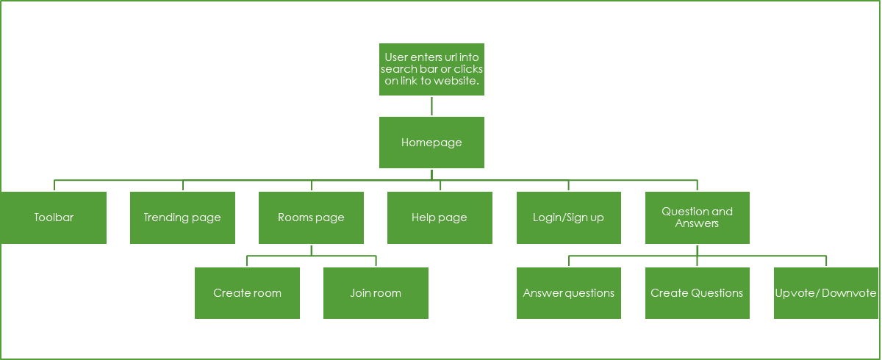

How the user interacts with the website

### How the user interacts with a website analysis

The user, once entering the URL, will be taken to the homepage. The layout of the homepage will be separately able to be configured within Django using the template feature. Templates are created using HTML

#### Homepage

The homepage is necessary as the initial part of the website that the user interacts with. On the homepage there will be links to different pages of the site like:

#### Questions and answers

Questions and answers is the main function of the website will be able to be coded within python through Django. This will encompass everything including the creating and answering of questions. This section of the website will be individually coded using decomposition into different modules. The upvote/downvote system will be a separately coded module on the page that will also be able to rank questions asked. There will be an option to save questions if you are logged in.

This section will be on its own individual page to make it easier

#### Login/signup

The login/signup page is where users will be able to log into a previously made account or create a new one to be stored in the database. This page is necessary if users wish to save questions or answer questions, so users must create an account if they want to get the full usage out of the website.

#### Help

The help page will be an informative page that directs users on how the website operates and what to do if they’re stuck or have an issue.

#### Toolbar

The toolbar allows for users to quickly access different sections of the website with ease by offering links leading to important pages on the site, e.g., homepage, help, rooms page, etc. This makes the site more easily navigable for users.

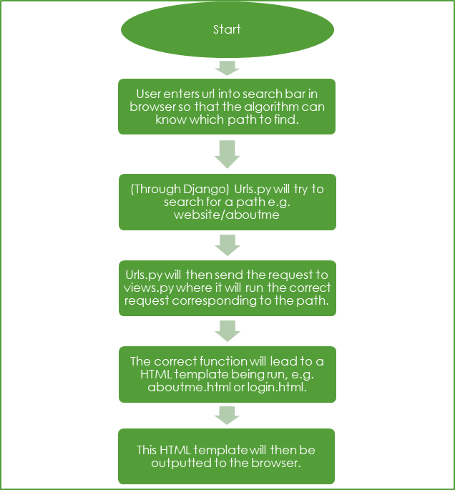

How Django outputs a webpage

#### Summary

First the user will enter the URL of the website into the search on their web browser. Django will then search for the corresponding path that is entered.

## Usability features

A clear layout

Buttons and all elements will be evenly spaced so that users can clearly view and interact with the website. Having elements separated and clearly labelled will make the website easier to read and less complex.

A toolbar/dropdown menu

Having links to other pages in the site compacted into a toolbar or dropdown menu will free up space on the homepage for other information and making it more readable.

### A help page

If a user is confused in any way or has an issue, they can navigate to the help page which will show them how the website works and how to interact with it. This will reduce the confusion that some users experience making the website more useable.

Well formatted content

Most users don’t read all of the information on a webpage and instead skim through the page. Having a well formatted page with outlined headings, subheadings, paragraphs and other elements allows users to quickly identify information that they are looking for.

### Usable Forms

Forms are very important to the usability of most websites, especially this one. They are integral in creating questions, answers, registering and logging in to the page. This needs to work seamlessly with the backend of the website so that users can easily access and input content.

## Algorithms of the code

### Register

class RegisterView(FormView):  
  
 @method_decorator(csrf_exempt)  
 function dispatch(self, request, *args, **kwargs):  
 return super(RegisterView, self).dispatch(request, *args, **kwargs)

endfunction  
  
 **# Method that retrieves user data from database and renders it (GET)**

function get(self, request)  
 content = {}  
 content['form'] = RegisterForm  
 return render(request, 'register.html', content)  
 endfunction

**# Method that adds new user data entered from register page to database but also checks if it's valid (form.is.valid), e.g. password length, characters and symbols, etc.** function post(self, request)  
 content = {}  
 form = RegisterForm(request.POST, request.FILES or None)  
 if form.is_valid():  
 save_it = form.save(commit=False)  
 save_it.password = make_password(form.cleaned_data['password'])  
 save_it.save()  
 login(request, save_it)  
 return redirect(reverse('dashboard-view'))  
 content['form'] = form  
 template = 'register.html'  
 return render(request, template, content)

endfunction

Figure - Register flowchart

### Login

class LoginView(FormView):  
  
 content = {}  
 content['form'] = LoginForm  
  
 @method_decorator(csrf_exempt)  
 function dispatch(self, request, *args, **kwargs):  
 return super(LoginView, self).dispatch(request, *args, **kwargs)  
 endfunction

**# Method that retrieves user data from database and renders it (GET)** function get(self, request):  
 content = {}  
 if request.user.is_authenticated:  
 return redirect('questions_list')  
 content['form'] = LoginForm  
 return render(request, 'login.html', content)

endfunction

**# Method that sends login details to database to be checked if they match a user**

function post(self, request):  
 content = {}  
 email = request.POST['email']  
 password = request.POST['password']  
 try:  
 users = User.objects.filter(email=email)  
 user = authenticate(request, username=users.first().username, password=password)  
 login(request, user)  
 return redirect('')  
 except Exception as e:  
 content = {}  
 content['form'] = LoginForm  
 content['error'] = 'Unable to login with provided credentials' + e  
 return render_to_response('login.html', content)

endfunction

Figure 2 - Login Flowchart

These two algorithms come together to answer requirement 3 which is the ability to create a unique user.

Requirement 4 is then answered then answered by the following algorithms that handle question and answer creation:

### Questions

class Questions(models.Model):  
 **#fields and other data**  
 user = models.ForeignKey(settings.AUTH_USER_MODEL,

on_delete=models.CASCADE, null=True, blank=True)  
 title = models.TextField()  
 description = models.TextField(null=True, blank=True)  
 points = models.IntegerField(default=0)  
 group = models.ForeignKey('QuestionGroups',

on_delete=models.CASCADE, null=True, blank=True)

created_on = models.DateTimeField(auto_now=True)  
 updated_on = models.DateTimeField(auto_now_add=True)  
 slug = models.SlugField(unique=True, null=True, blank=True)  
  
 **#creates a slug of from the title of a Question**  
 def save(self, *args, **kwargs):  
 self.slug = slugify(self.title)  
 super(Questions, self).save(*args, **kwargs)  
  
 **#changes unicode within admin page to object 'title'**  
 def __unicode__(self):  
 return self.title

**#changes str within admin page to object 'title'**  
 def __str__(self):  
 return self.title

### Question Form

class QuestionForm(forms.ModelForm):  
  
 title = forms.CharField(max_length=90, required=True)  
 description = forms.CharField(required=True, widget=forms.Textarea())  
  
 class Meta:  
 # Inherits data and fields from the 'Questions' model class  
 model = Questions  
 # The fields that will be displayed in the form  
 fields = [ 'title', 'description', 'group']

### Answers

class Answers(models.Model):  
 **#fields and other data**  
 user = models.ForeignKey(settings.AUTH_USER_MODEL, on_delete=models.CASCADE)  
 **#takes in the id of the question that is being answered**  
 question = models.ForeignKey(Questions, on_delete=models.CASCADE)  
 **#users entered answer**  
 answer = models.TextField()  
 created_on = models.DateTimeField(auto_now=True)  
 is_anonymous = models.BooleanField(default=False)  
  
  
 def __unicode__(self):  
 return self.id

### Answer Form

class AnswerForm(forms.ModelForm):  
 class Meta:  
 **# Inherits data and fields from the 'Answers' model class**  
 model = Answers  
 **# The field that is displayed in the form**  
 fields = ['answer']

## User interfaces

### Login and Registration

The Login and Registration UI is going to be simple showing a main title followed by forms for each field in a user’s account. These fields will be email and password for the login page and username, password and email for the registration page.

Figure - Login and Register page examples

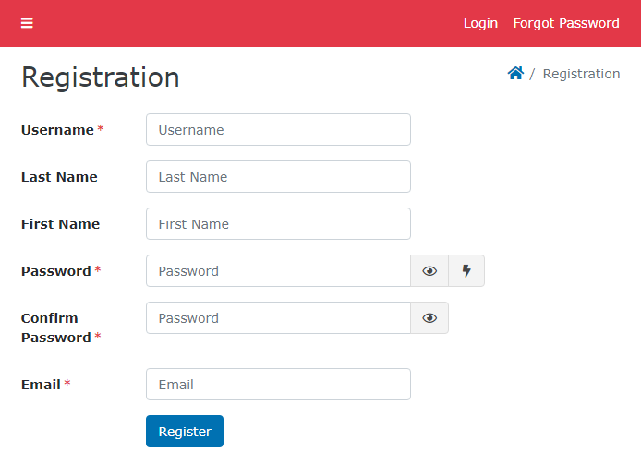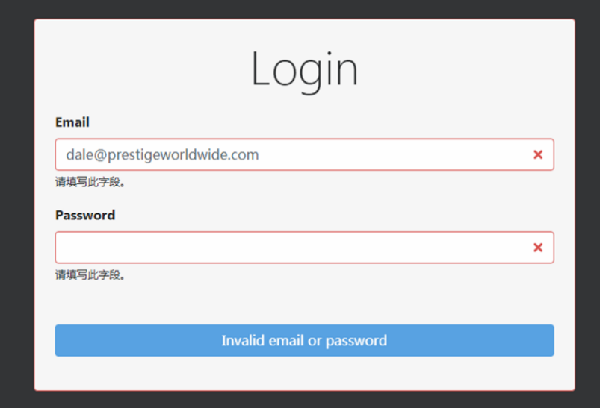

### Dashboard/ Homepage

The Dashboard page will be similar to Quora and StackOverflow in the way that it will have a toolbar at the top and a footer at the bottom linking to the different webpages. It will then have a main section in the middle where the page will display the questions and answers in an organised format showing the question title, the number of answers and the date it was created.

Figure - Rough sketch of Dashboard page

Questions and Answers

Why is primary structure important in proteins? (3 solutions)

Is the Krebs cycle that important to respiration? (2 solutions)

Toolbar

Footer

Logo

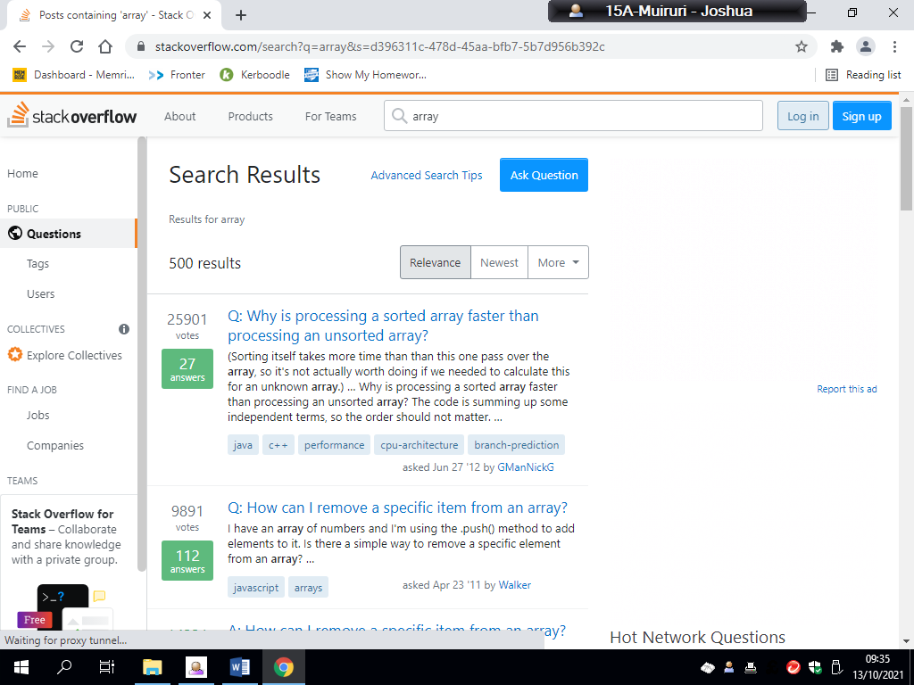

Figure - Dashboard/home page example on stack overflow

## Key components

|  |  |  |
| --- | --- | --- |
| Name | Type | Justification |
| RegisterView() | Class | Allows the user to create unique account that when rendered in conjunction with html will display a form for account creation. |
| LoginView() | Class | Allows the user to login to an account that they created previously using the RegisterView class. It also redirects them to the homepage. |
| Questions() | Class | Manages the creation of questions that are linked to users. |
| Answers() | Class | Manages the creation and linking of answers to objects from the Questions class. |
| QuestionGroup() | Class | Manages the different topics that questions can fall into, for example respiration. |
| questions_list() | Function | Aids in the rendering of the homepage where all of the current questions are displayed. |
| questions_page() | Function | Aids in the rendering of each questions individual page. |
| db.sqlite3 | Database file | Holds information about requests made by clients and the server to run the website. |
| search_view() | Function | Allows the user to search through topics and names in the database. It queries through these fields and displays links to the resulting questions. |
| question_form() | Function | Aids in the rendering of a form that allows users of the page to create their own questions that can be answered by other users. |
|  |  |  |

## Test Plan

|  |  |  |  |  |  |
| --- | --- | --- | --- | --- | --- |
| Test No. | Test | Test Type | Test Data | Justification | Expected Output |
| 1 | Test fields on register page | Invalid | Leaving field blank | To test to see if the register form will still move data into the database without all required fields | The website, before sending data to Django will prevent the user posting the data to the database and from going forward to the dashboard. The website should display a popup box that prompts the user to enter data into the fields left open. |
| 2 | Test password on register page | Invalid | Entering a simple password with no numbers | To test to see if the website will flag an invalid password. | The website should show a popup signifying that the user has entered an invalid password and that they need to change it |
| 3 | Test login system on login page | Invalid | Entering incorrect data | To test if the website will prevent you from logging in to the site if you enter the wrong data. | The website, before sending data to Django will prevent the user posting the data to the database and from going forward to the dashboard. The website should display a popup box that prompts the user to enter data into the fields left open. |
| 4 | Test search bar | Invalid | Leaving search bar blank | This is to see if the search bar algorithm will realise that nothing has been searched and will output a suitable response for the user. | The page should still render but instead of showing the results of the search it will print a message like “You didn’t enter anything for this search,” to tell the user what they had done. |
| 5 | Test search bar | extreme | Entering a topic that doesn’t exist or isn’t spelt right | This is to see if the that the algorithm can show that something was searched but didn’t exist in the database | The page should render and should output text saying that “The item that that you searched isn’t found or is spelt wrongly” |
| 6 | Test search bar | valid | Entering a topic that exists | This is to see that the search algorithm works and displays the correct questions to be accessed by the user. | The page should render and should output text saying, “Showing the results for search” and will show the questions that matched the topic of the search. It will also have links to each question page. |
| 7 | Test Question form | valid | All forms valid | This is to see if the form data is taken by the website and transferred to the database. | After the submit button is pressed on the form the user should be redirected and the form should appear in the admin section of the site. Also, the new question should appear on the homepage. |
| 8 | Test Question form | invalid | Description field empty on the form | This is to see if the form will reject an invalid form. | A popup should appear after the submit button is pressed saying that the empty field needs to be entered. |
| 9 | Test Question form | extreme | Title with more than 90 characters | This is to see if the form will reject an invalid form. | The form shouldn’t let you input anymore characters once this threshold is reached. |
| 10 | Test Answer form | valid | All forms valid | To see if the Answer form transfers data to the database. | After submitting the form, the page should be refreshed and the answer that was entered should show up underneath the question. |

## Post Development Questionnaire

After the development process I am going to be using a questionnaire to assess my program, and see any improvements I will make, this is because a questionnaire is a very easy and useful way to gather my stakeholders’ opinions and is in a similar style of gathering their requirements, so the stakeholders will be familiar and comfortable with this method of gathering their opinions. It can also give me a lot of qualitative data that I can take into account and can target areas of the program that I would like to improve with targeted questions, for example, asking about the graphics of the website and asking how to make them better.

1. What do you think about the overall layout of the website?
2. How could the website function be improved?
3. How informative is the UI of the website?
4. Do you suggest any changes to the UI?

# Development

## First Prototype

To start, I first started developing the registration and login systems of the website.

### Registration page/backend

Figure - The form for the register page

This register form class outlines the fields that each user will have like first name, last name and the password. This is then imported to the Register View where it is used.

Figure 7- The view for the register page

Here the view takes the form in figure 7 and renders it on the register page. This section of the code is called a GET function. Next in the POST function data that is entered by the user is processed to check if it is valid, for example a password being too short. If it is valid the user’s details are stored within the database.

Figure 8 - HTML template for register page

This HTML uses simple Django syntax called “form.as.table” to render the form as a HTML table.

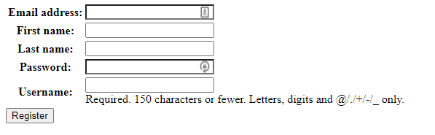

Figure 9- simple register page displayed from the previous code combined

On this basic register page, you are able to enter your details like email, name and password. Through the use of the code above Django is able to POST (transfer) all of this data to the sites SQL database creating a new user object. This form is also able to prevent the data from being passed to the if certain criteria aren’t met like for example if the password used invalid symbols, it would be rejected.

This register page in the first prototype doesn’t visually look the best since I haven’t included CSS in the html template that is rendered but also since I prioritised the function of the page first before the look of it. I can build on the look in future prototypes.

### Login page/backend

Figure 10- The form for the login page

Figure 11 - The view for the login page

The GET function here retrieves the form and renders it when the page is started. The POST function takes the information the user entered to login and sends it to the database to be checked.

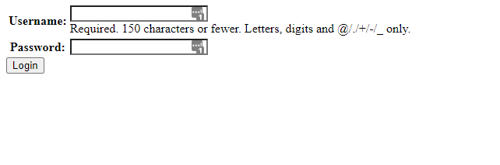

Figure 12 - simple login page rendered from the previous code

On this basic login page, you are able to enter your details like email and password. Through the use of the code above Django is able to GET (retrieve) the user data for your account by scanning through the SQL database to find. This form is also able to prevent the data from being passed to the if certain criteria aren’t met like for example if the password used invalid symbols, it would be rejected.

This register page in the first prototype doesn’t visually look the best since I haven’t included CSS in the html template that is rendered but also since I prioritised the function of the page first before the look of it. I can build on the look in future prototypes.

Also, to start the project I created a new file for my project called Coursework where I created a virtual python environment and then installed Django into the directory. From there I was able to create my Django project.

### Alpha Testing for Prototype 1

I am initially doing testing to see if the register and login pages function correctly, allowing the entering of data/information but also if they reject invalid data from being entered.

#### Test if register page allows multiple usernames of the same name

Here I am testing to see if the website will prevent a user being created with the same username as someone else.

#### Test if register page prevents invalid data

Here I am testing to see if the register page prevents invalid data, in this case blank fields from being transferred to the database. The page should show a popup box to enter the required field. Also, I slightly altered the register form (Figure 4) to be more logically ordered as shown below:

Figure 13 - Invalid data test image 1

In the image above I have opened the register page and have entered information into all the fields except for the username field. I will then click the Sign-up button to attempt to send the data to the database.

Figure 14 - Invalid data test image 2

After I clicked the button, the result was as follows. A popup window/warning message appearing below the empty field telling the user to fill in the field. This test applies to all basic fields except for first name and last name since in the form code I set it so that they weren’t required:



This test was a success.

### Test if register page prevents invalid password

Essentially, I’m going to carry out the same test as above except instead of leaving a field blank, I am going to enter data into all the fields, but instead the password is going to be invalid. The password is supposed to be more than 8 characters so I will enter a password without with 6 characters (joshmu). The website should print an error popup.

Figure 15 - Invalid password test

Figure 16 - Invalid password test pt2

Instead of stopping the user from being registered they were added to the database and were redirected to a mock-up homepage.

This test was a failure

### Test if register page posts details to database

In this test I will be testing to see if the information I passed into the register page was successfully transferred into the database. To check this, I will use the hidden admin section that comes with Django. There I will be able to view if the new user was added. Also, I will check the command-line of the server in windows PowerShell for further validation.

Figure 17 - Valid data entered into register page

The password entered is “passw0rd1” which is valid.

Figure 18 - Result after registering

After pressing the Sign-up button the website redirected me to the homepage where it showed proof that the user was created since it output “Welcome, j.real” which is the username I inputted.

Figure - Django admin page

Figure 20 - Django admin page

In these three images the Django admin page shows proof that the data entered has been added to the database as a new user object. The user is listed with the other users in admin. You are able to login on the login page using this users’ credentials now. The password is also hashed to improve security.

Figure 21 - image of PowerShell command prompt

Here the server command prompt shows that the data was POSTED to the database.

This test was a success

### What requirements have been fulfilled?

This prototype fulfils the 3rd general requirement which was allowing users of the website to create a personal user profile where they can store and answer questions. Even though I haven’t completed the second part of this, I will be able to build on it in future prototypes.

Also, this prototype fulfils the 1st general requirement which is for the website to be able to work on a range of different web browsers. Since the page is rendered in HTML it can be rendered on all popular browsers like Chrome, Edge, Explorer and Firefox.

### What do the Stakeholders say?

With the feedback given the majority of my stakeholders said that they like the fact that they can make a unique account since allows them to access their questions and data from anywhere. Although the stakeholders that are students (Stephen and Kwame) would like the website to visually look better because it looks very simple and difficult to navigate. Therefore, in the next prototype I aim to improve how the website looks and navigates by fulfilling my 5th and 6th general requirements.

### What to improve for this prototype:

1. The graphics right now are only placeholders for how the final product will look since currently I’m only focusing on the functionality of the website first. So, in a later prototype I will improve the graphics
2. Adding a toolbar since it is a key part of website allowing the user to navigate around between pages easily.
3. In developing the taskbar, I will also include a working search bar that searches through all the current questions and displays the result.
4. I need to implement the main part of the site where questions and answers are displayed but also you can create and answer them.

## Second Prototype

In this prototype I’ve started developing the toolbar for the website making other pages easier navigable.

### Text Description automatically generatedText Description automatically generatedToolbar

Figure 22 - HTML for Toolbar

When rendered, this HTML code creates a navigation bar on every single page of the website allowing user to navigate throughout the website to all the pages they need. The buttons created in the navigation bar use Django syntax to link to different urls in the .urls file as shown in the previous prototype. This is shown rendered in the next image.

I haven’t added the search bar functionality so I will do that next.

Figure 23 - Image of dropdown menu

Figure 24 - Image of displayed navigation bar

### Search bar

Next, I coded the HTML for the search bar which I placed at the end of navbar code so that it’s out of the way. When fully integrated with the rest of my Django project the website the search bar will first take an input of a topic that you want to search for. Django will then go to the database of questions and search for items that match the topic inputted. When the search button is pressed, it will link to a page that displays a query for the questions.

Figure - Image of search bar added

Figure - HTML for search bar

Currently I have attempted to implement the backend of the search bar to make it send you to a different page and display the results of the search. Unfortunately, right now it is not working even though I entered something and gives me this error:



Figure - Proof that something was entered

### What requirements were fulfilled?

This prototype fulfilled the 5th and 6th general requirements which was first to create a toolbar that links to most of the main page like home, login, sign up and others. Secondly the 6th requirement was to create a search bar that would search through all of the questions and return a filtered result. Although this is only partially met since the search bar isn’t completely functional.

This prototype fulfils the 3rd general requirement which was allowing users of the website to create a personal user profile where they can store and answer questions. Even though I haven’t completed the second part of this, I will be able to build on it in future prototypes.

Also, this prototype fulfils the 1st general requirement which is for the website to be able to work on a range of different web browsers. Since the page is rendered in HTML it can be rendered on all popular browsers like Chrome, Edge, Explorer and Firefox.

### What do the stakeholders say?

1. Most of the stakeholders say that they are happy with the progress that is being made on the website.
2. The improvement to the graphical interface when adding the toolbar has made the page more user friendly.
3. The site is responsive when moving between pages
4. The site is still useless since the question-and-answer function hasn’t been implemented yet.
5. Currently the search bar is useless.

### What to improve for this prototype:

The main focus is to implement and code the question-and-answer function of the website. After this is done the main section of the site will be complete and any other further improvements will be minor or graphical.

## Third Prototype

### Questions

In this final prototype I am addressing the main feature of this site which is to create questions and answers. This will address the homepage which will display all of the most viewed questions and will have links to each question.

Figure 28 - view for Homepage

This function imports details from the questions class stored in the database and allows it to be accessed by the homepage.

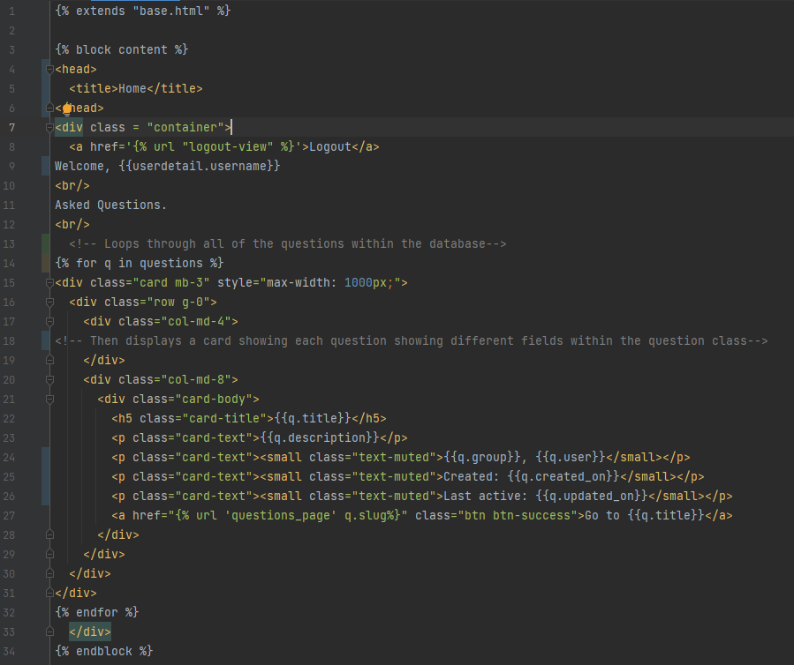

Figure - HTML for Homepage

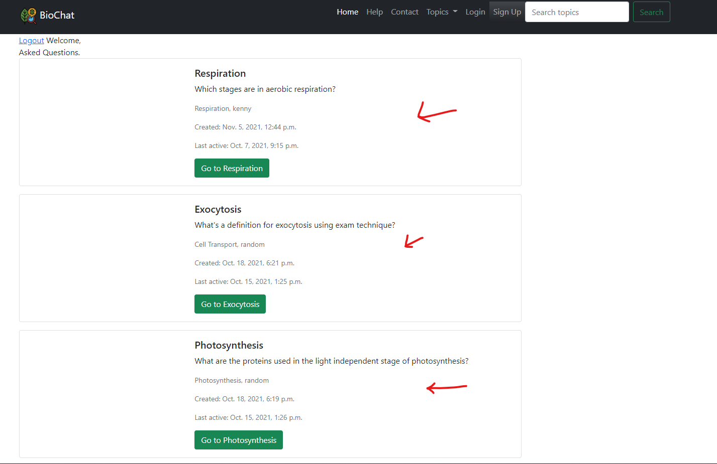

Figure - Rendered page from HTML

The combination of the view and HTML page results in a webpage being displayed. On this page is the toolbar with all its links and the question cards which display the title and description of the card defined in the database followed by a green button linking to the slug page for the given question. These questions are displayed in order of popularity in terms of clicks. Although it appears that the function that retrieves the users name failed even though I was logged in at this point.

### Test if question buttons work

Here I am testing to see if the question buttons correctly link to the right pages.

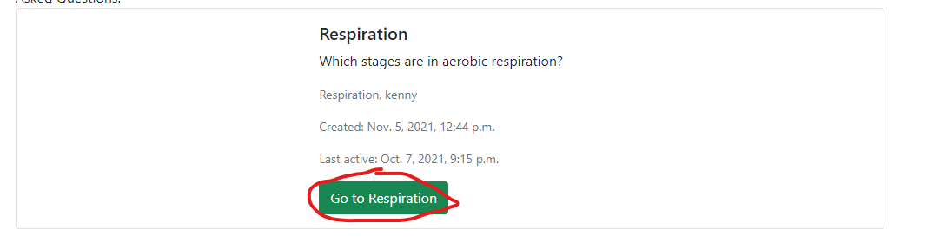

Figure - Button test1

When pressed this button should link to the respiration question page which I am going to show after this test.

After the button was pressed, the website was redirected to the question page for respiration.

This makes this test a success

### Question page

Here I am developing the question page which will link off each individual question on the homepage. This question page will contain all details of the question like the description and user but will also include answers to the question submitted by other users.

Figure - View for the Question page

This function takes in a slug as a parameter which is a variable within the question class. The slug acts a way to identify each individual question object in order to add it to the end of the web link. The function then finds the question that this slug links to and gives the web page access to all of its details. This allows the page to render out all the question’s details like title, topic, description, user and start date.

The function also finds any answers that were made for this question and renders their content.

At the bottom of the page there will also be a way to submit answers in a form, but I have not programmed that in yet.

Figure - HTML for Question page

This HTML code then takes the function from the above view and renders it as a page. It renders the question and answers in a card shape as shown below. Graphical user interface, text, application, email

Figure - Image of mock-up Question page

### Question creation

Now I am going to program in a page allowing you to create your own questions to be answered.

Figure - Model for Questions app

This is the model for the Questions functionality of the website. This was previously used when in the creation of each question page and the homepage.

Figure - Question form class

Shown above is the Question Form class that designates fields within the question creation form. This form class inherits the fields from the ‘Questions’ model (see Figure 35). This form is then transferred to the form creation view shown below.

Figure - view to render form

This view function not only deals with rendering the form on the page but also handles when a form is submitted. When a form is successfully submitted, it should link to a confirmation page. Before this though, the HTML for the form submission page is first rendered.

Figure - HTML for Question submission form

All that code combined renders this page.

Figure - Rendered form submission page

On this page you can fill out the form to create a question which can then be interacted with and seen by other users.

### Test to see if form page works properly

When the submit button is pressed the user should be redirected to a success page.

Figure - data entered for test

When clicked the button redirected the page to the success page showing a message and a button to go home.

This test was a success

### Test to see if form is saved

I am testing to see if when filled, that the form is submitted to the database. The new question should show up on the homepage and admin.

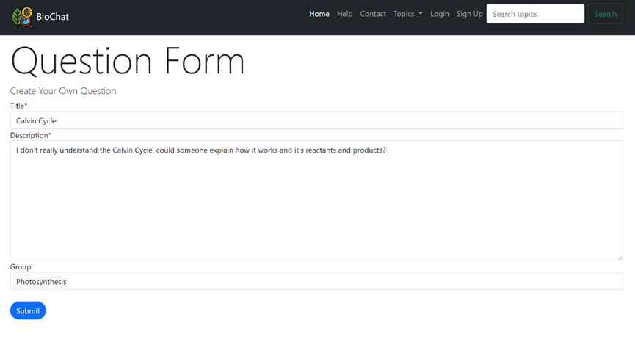

Figure - Data entered for test

When clicked the page was redirected to the success page. Going back to the homepage we can see if a new Question was really created.

Figure - Form test

This image shows that at the bottom of the page a new question was created

This test was a success

Now I am going to create an answer form that is displayed at the bottom of the page:

Figure - Model for answers

This is the model for the Answers functionality of the website.

Figure – Form for Answers

This form inherits the fields and data from the Answers model class.

Figure - Altered view for the question page

The question_page view is altered to handle the answer form and the request.

Figure - HTML for new Question page

Figure - Rendered new question page with answer form

The combination of the view, form and html results in the rendering of this new question page. A comment form is rendered underneath the question and answers where users can comment on the page.

### Updated Graphics

As requested by the stakeholders I updated the graphics of the Register and Login pages to make them look more modern.

Figure - Updated Register page HTML

Figure - Updated Register page

This update to the register page has a more modern appearance. Go to Figure 9 to compare the difference.

Figure 50 - HTML for new Login page

This altered login HTML applies a CSS library called ‘crispy forms’ to the login form making it look more modern.

Figure 51 - Page rendered for new Login page

### Fixed Search bar

I was also able to fix the faulty search bar by checking my code. I had realised that I had not included the method within the form tag on HTML. This resulted in the search_view function not registering the ‘request’ as POST. In the next few images this fix is shown:

Figure - Updated form in base HTML

Figure - Resulting search page

### Test for search bar

In this test I will be

### What requirements were fulfilled?

This prototype fulfilled the 4th requirement to create question and answer forums, which is arguably the most integral requirement to the purpose of the website. This was long overdue to be implemented into the final prototype which has left the stakeholders confused and upset throughout development. Secondly the 6th requirement to create a search bar was completely fulfilled since it is working properly now unlike in prototype two.

### What do the stakeholders say?

1. All the stakeholders say that they are happy with the outcome of the website since it allows them to easily create questions and answers to exchange among a large group of users, creating a community of sorts.
2. The UI and graphics of the website is adequate and has only improved as the development has continued, although both of my student stakeholders Stephen and Kwame both say that “even though the UI is modern is does seem a bit empty and dull at times”
3. The site is responsive when moving between pages
4. They are happy that the search bar is finally functional since it is the main way of accessing questions outside of the homepage.

### What to improve for this prototype:

This is the final prototype – but if I was to improve upon it – I would get more feedback on how the stakeholders would like the UI to change since some of them were unhappy with how it currently is.

Also, I would implement the room functionality from my 6th requirement which would satisfy my stakeholders that are teachers.

# Evaluation

## Testing

Here I will be carrying out tests that are in line with my test plan and below the table I will show all the evidence:

|  |  |  |  |
| --- | --- | --- | --- |
| Test No. | Test | Explanation | Result |
| 1 | Test fields on register page | To test to see if the register form will still move data into the database without all required fields | Pass |
| 2 | Test password on register page | To test to see if the website will flag an invalid password. | Fail |
| 3 | Test login system on login page | To test if the website will prevent you from logging in to the site if you enter the wrong data. | Pass |
| 4 | Test search bar | This is to see if the search bar algorithm will realise that nothing has been searched and will output a suitable response for the user. | Pass |
| 5 | Test search bar | This is to see if the that the algorithm can show that something was searched but didn’t exist in the database | Pass |
| 6 | Test search bar | This is to see that the search algorithm works and displays the correct questions to be accessed by the user. | Pass |
| 7 | Test Question form | This is to see if the form data is taken by the website and transferred to the database. | Pass |
| 8 | Test Question form | This is to see if the form will reject an invalid form. | Pass |
| 9 | Test Question form | This is to see if the form will reject an invalid form. | Pass |
| 10 | Test Answer form | To see if the Answer form transfers data to the database. | Pass |

## Graphical user interface, text, application Description automatically generatedGraphical user interface, application Description automatically generatedTest Evidence

Figure 54 - Test 1 Evidence

Figure 55 - Test 2 Evidence pt1

Figure 56 - Test 2 Evidence pt2

Figure - Test 3 Evidence pt1

The password for this form is incorrect.

Figure - Test 3 Evidence pt2

Figure 58 - Test 4 Evidence

Figure - Test 5 Evidence

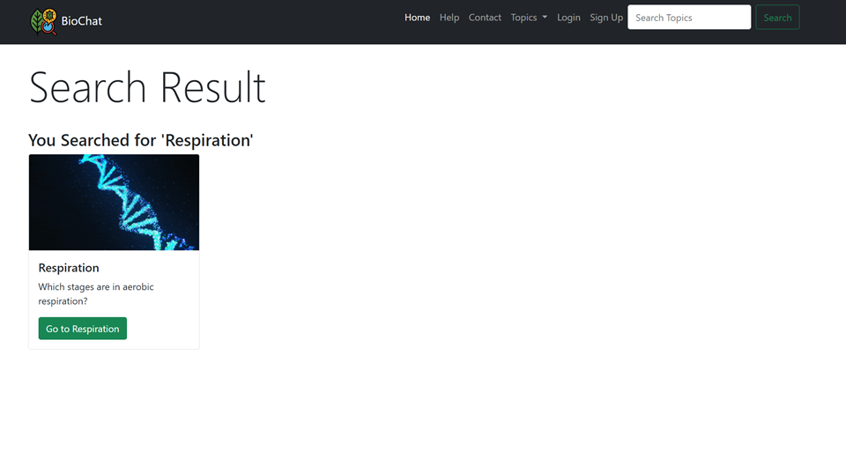

Figure 61 - Test 6 Evidence pt1



Figure 62 - Test 6 Evidence pt2

Figure 63 - Test 7 Evidence pt1

Figure 64 - Test 7 Evidence pt2

Figure 65 - Test 8 Evidence

90 characters reached

Figure 66 - Test 9 Evidence

The form doesn’t allow you to input any more characters after the threshold of 90 is reached.

Figure 67 - Test 10 Evidence pt1

Figure 68 - Test 10 Evidence pt2

## Failed Tests

The only failed test that I encountered was with test no.3. Here a correct email but incorrect password was entered to login to the website.

Figure 69 - Failed test

Figure 70 - Failed test

Which produced an error, crashing the page. Through analysing the code, I was able to work out that there was an error with the last part of my Login view class, particularly the code that deals with errors.

Figure 71 - Code causing error

As the error states the function is not able to output the code since the error message of ‘Unable to login with provided credentials’ clashes with the exception since it is not in string.

To solve this issue I would need to find where the exception is sent to forcibly change it into string with the “”str()” method in python.

## Post development questionnaire results

After the development was completed, I let my stakeholders use the website for a week to get their opinions on the outcome of the website. After the week I gave them a questionnaire (first made in the design) to answer about how well the site turned out:

1. What do you think about the overall layout of the website?
2. How could the website function be improved?
3. How informative is the UI of the website?
4. Do you suggest any changes to the UI?

Here are their results:

Stephen

1. The website looks modern, and the layout is clear since questions and answers are arranged in cards. The Toolbar also helps this clean, modern feel.
2. There’s not much that is really missing from the website I’m content with how it works
3. The UI shows all the information that you need, the toolbar helping this simplicity work.
4. Maybe changing the colour scheme could bring a new flavour to the website not that I don’t like the green biology theme.

Kwame

1. The website looks better than I expected. All-important items are laid out on the homepage and the toolbar reducing the chance that you get lost.
2. The function of the website is really good. Although I wish I could access and customize my profile more for example with a profile picture.
3. The UI is very clean and informative
4. The UI looks perfect to me

Mr Smith

1. The layout of the website is surprisingly practical with all objects being spaced out evenly
2. The basic features currently are perfect, it’s just that I wanted the feature where I could make rooms for my individual classes.
3. The UI is very informative
4. The UI is perfect as it is

Dr Adekunle

1. The overall layout is clean and is better than my expectations. Everything I want to see is spread clearly on the website.
2. The functions implemented into the website currently are perfect and well built, it’s just I wanted teachers to be able to make rooms for classes that are invite-only.
3. The UI is pretty modern and is easy on the eyes
4. As a finished product the UI doesn’t need any changes.

## Usability Testing

|  |  |  |  |
| --- | --- | --- | --- |
| Feature | Evidence | Success | Justification |
| A clear layout |  | Success | Most users don’t read all the information on a webpage and instead skim through the page. Therefore, I’ve titled and added heading to all items on the page. |
| Toolbar |  | Success | The user can access most of the main pages of the website through clicking buttons on the toolbar. This reduces the chance of getting lost and being confused |
| Help page |  | Partial success | This feature is partially met since the page is implemented. The only issue is that no content has been added to help the user yet. So, the page isn’t populated yet but can easily be done. |
| Well formatted content |  | Success | Buttons and all elements are all evenly spaced so that users can clearly view and interact with the website. Having elements separated and clearly labelled will make the website easier to read and less complex. |
| Usable forms |  | Success | Forms like the one shown are easy to access and have clear titles for fields that need to be filled. |

## Maintenance

**Commented Code:**

Having commented code means that if any future programmers want to work on my code in the future, there is already notation and code there to make it easy to see what each function does in the code and explains lines of code and what they do. This helps with maintenance as if there needs to be any updates, it is less likely that a future programmer or even myself will make a mistake and delete a vital node for the program.

**Clear Variable Names:**

The variable names in the code are clear to understand, and they help to make future programmers understand the code as the variables directly connote to certain points in the code, making it easier to change the variables that are related to performance, and the code much easier to read and edit. This helps with maintenance as it means that the variables can be easily edited to improve the performance of the website and synergy between pages. It also improves the readability of the program for future updates.

**Formatting Spaces:**

Having spaces between functions, and the variables being loaded into the game, means that the code is much easier to read and understand. The spaces make it clear when chunks of code or functions are separated, and thus can help segment the code and make it easier to add future updates as the readability of the code is improved.

## Limitations

**Room’s function**

2 out my 4 stakeholders said in the analysis questionnaire that they would like the implementation of a rooms system where invite-only rooms could be made. This would have been for teachers and students alike since it could be used to separate the school from other users online. This would have also allowed students to be given direct feedback from their teachers easier.

Unfortunately, this was not able to be implemented in time for the end of the development. Although for future programmers, the backend work for question and user classes is already there so development of this feature wouldn’t be too difficult.

**Profile customization**

In the final website, users aren’t given much customization over their account. For this reason, other than for making questions there isn’t as much of an incentive for users to interact and answer questions. Features that could have solved this problem are allowing users to change their profile, adding bios that can be edited by the user, allowing users to change their username, etc.

**Tracking function**

This limitation follows on from the previous one in the fact that there are not many incentives to make users come back and interact on the site. Features like tracking the number of questions created and answered, tracking the upvotes gained from these Q&A’s. Also, unique ranks could have been assigned depending on the trackers previously mentioned. All these trackers together could have made interacting on the website more enjoyable, increasing its usage and traffic.

## Success Criteria Review

|  |  |  |  |
| --- | --- | --- | --- |
| Criteria | Evidence | Success | Justification |
| 1  *A way to create questions for other users to see* |  | Success | The main function of the website is to allow users to create and answer questions about biology which this form fulfils. This is the main function that starts the website turning into a community. The question, once made, is then displayed on the homepage and available to be found by search. |
| 2  *A way to put forward solutions to questions asked for all users so that you can interact with the website.* |  | Success | This allows users to answer questions that have been asked making the site feel more active and like a web community. Users can interact with each other and work together to solve questions. |
| 3  *A way to upvote and down vote questions and answers so that they can be organised to where the answers with more upvotes are shown first.* | **This criterion was not met.** | Failure | I was not able to implement the upvote and downvote functionality of the questions. This because I couldn’t link a working button to the points field to my Question class in the time I was given to complete development. |
| 4  *Working and able to run in any browser.* | No evidence required, check justification. | Success | The website can run on any browser as long as the server is on. This is possible because the actual rendering of the website is done using HTML which can be run on all common browsers like Chrome, Edge, Firefox, Opera, etc. |
| 5  *A search bar where you can search and sort through all the questions or topics in the websites database* |  | Success | Gives users easier access to all the questions in the database. Quicker than scrolling through the homepage. |
| 6  *A toolbar at the top of the website where there are links to different parts of the website which makes traversing the website easier.* |  | Success | Makes traversing the website easier for users since there are clear buttons leading to subsequent pages. Increase usability. |
| 7  *A way to create an account on the website allowing features like saving questions so that people will be more likely to use the website more often.* |  | Success | Allows users of the website to create unique profiles that are used to save and answer questions. |

## Solution for Unmet criteria

**Criterion 3**

I was unable to create a success ranking system through upvotes and downvotes due to a strain on time when completing the development. To successfully implement this feature, I have an idea of how I would do it.

I would need to link a button on my question page to a specific function within my Question class that increases the value of the points field although it is difficult to show this on the page without refreshing. To do this I would need to integrate the use of an API called “HTMX” that deals with AJAX requests, that update the page in real time. This would allow the user to upvote and downvote questions and answers seeing the effects in real time.

Furthermore, this would allow me to implement a system where questions are displayed by descending order depending on how many points they have. This could be effectively used to create a “trending” page to show the most active and popular question at the given time.